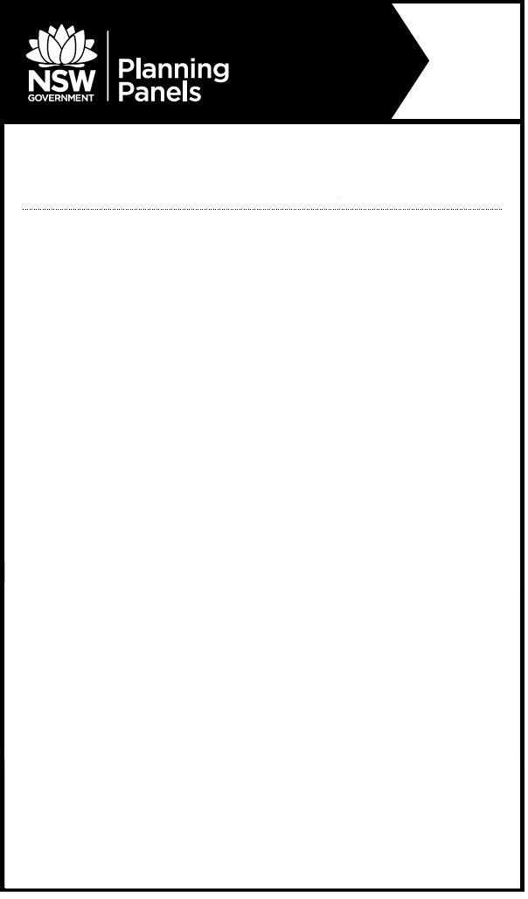

**Notice of Public Meeting**

**Sydney Central City**  **Planning Panel**

The panel will meet to determine the following:

PPSSCC-447 – Cumberland – DA2023/0130 – 109A Church Street, Lidcombe - Demolition of existing buildings and construction and operation of an organic waste transfer station. The proposal is Integrated Development pursuant to Section 43(b) of Protection of the Environment Operations Act 1997. The proposal is also Designated Development pursuant to Schedule 3, Section 45(2) of the Environmental Planning and Assessment Regulation 2021.

**When:** Thursday, 7 March 2024 at 11:00am

**Where:** The meeting will be held by public videoconference

Relevant documents are available on the Planning Panels website [www.planningportal.nsw.gov.au/planningpanels](http://www.planningportal.nsw.gov.au/planningpanels)

To register to speak or to listen to this meeting, please contact the Planning Panels Secretariat before 4pm on Tuesday, 5 March 2024 02 8217 2060 or email [enquiry@planningpanels.nsw.gov.au](mailto:enquiry@planningpanels.nsw.gov.au). You will be provided the details to enable you to join the public videoconference once registered.

The panel is required to make an audio record of the meeting and make the recording publicly available on the Planning Panels website. You should be aware that this may include your personal information if you are presenting to the panel.

**For more information:** (02) 8217 2060

www.planningportal.nsw.gov.au/planningpanels